**9А-10.04.2020г. 9Б-13.04.2020 9В-14.04.2020г.**

**Тема: «Необычная школа»**

[**https://www.youtube.com/watch?v=fEJHY8kF0bs**](https://www.youtube.com/watch?v=fEJHY8kF0bs)

**Step 3**

**DO IT TOGETHER**

**Аудирование**

**Ex 1 pp 69-70**

**Грамматика (Complex Object) Сложное дополнение**

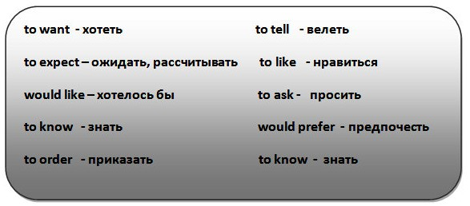

[**https://www.youtube.com/watch?v=nnmaNkNHUeI**](https://www.youtube.com/watch?v=nnmaNkNHUeI)

**Ex 2 p 70 Read**

**Ex 3 p 71**

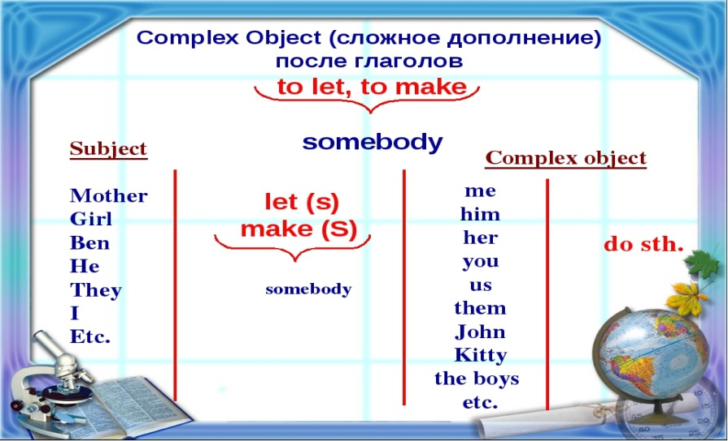

**HOMEWORK**

**Ex 4 p 71**

**9А-11.04.2020г. 9Б-17.04.2020г. 9В-15.04.2020г.**

**Тема: «Подростки и домашние питомцы»**



**Ex 6 p 77 Read the text «Pets»**

**Грамматика (Complex Object) p 77**

**Ex 5 p 76 перевод**

**DO IT ONE YOUR OWN**

**Ex 9,10,11 p 78**

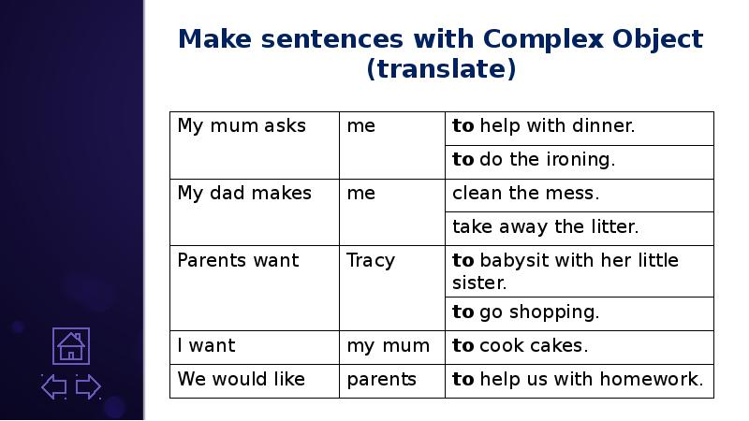

**HOMEWORK**

**Ex 2 p 76 Соотнести**

**Ex 4 p 76**

**9А-16.04.2020г. 9Б-18.04.2020г. 9В-18.04.2020г.**

**Тема: «Кумиры подростков »**

  



**Ex 1 p 79 (A) Аудирование (62)**

**(B) читать досье**

**Ex 3 pp 80-81 Продолжить историю Энди**

**HOMEWORK**

**Напишите досье про своего кумира**

**Угодай кто?**

[**https://zen.yandex.com/media/id/5d53e7fd14f98000ad343e81/viktorina-ugadai-kumira-molodeji-5d5668dfa06eafb7bab3510b**](https://zen.yandex.com/media/id/5d53e7fd14f98000ad343e81/viktorina-ugadai-kumira-molodeji-5d5668dfa06eafb7bab3510b)

**9А-17.04.2020г. .9Б-20.04.2020г. 9В-21.04.2020г.**

**Тема: «Проблемы отцов и детей »**



**Ex 4 p 81 read the text «Teens and Parents»**

**Ex 5 p 81 Ответить на вопросы**

**Complex Object**

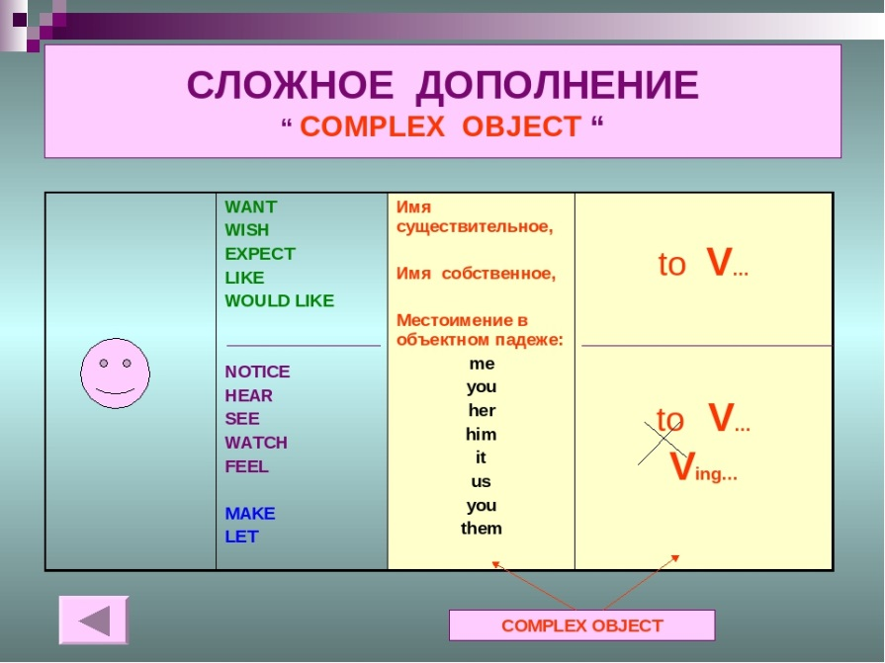

**HOMEWORK**

**Ex 6 p 82 Исправить ошибки в некоторых предложениях**

**9А-18.04.2020г. 9Б-24.04.2020г. 9В-22.04.2020г.**

**Тема: «Подросток и его окружение»**

 

**Ex 9 p 84 Составить предложения**

**Ex 11 p 84 Составить диолог используя таблицу Social English на стр 82**

**Ex 12 p 84 Письмо другу**

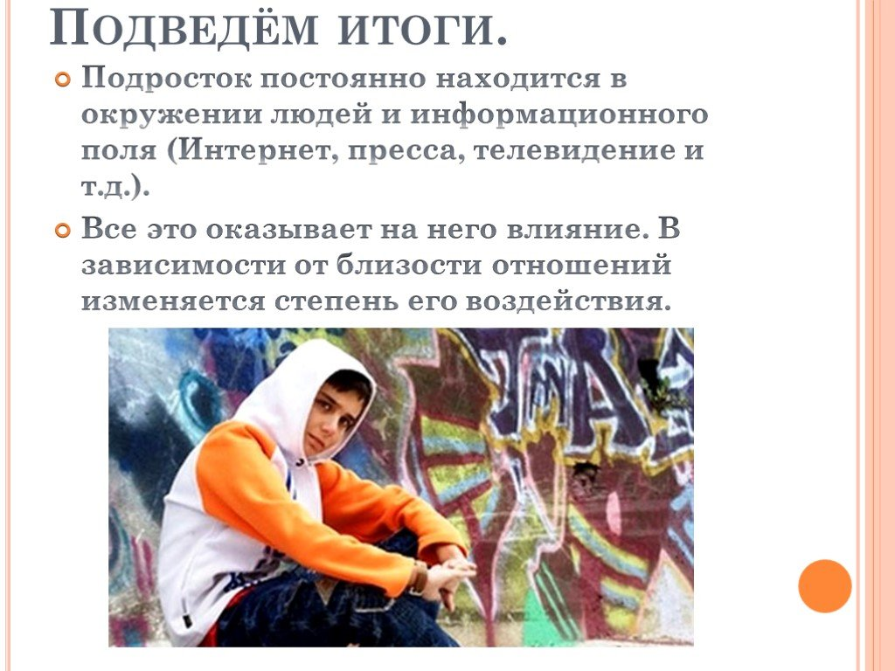

**HOMEWORK**

**Ex 3 p 85-86(A,B) Учить**

**9А-23.04.2020г. 9Б-25.04.2020г. 9В-25.04.2020г.**

**Тема: «Расизм в Британии»**



**Ex 6 p 87 (А) What is racism? Do you think it exists in Britain ?**

**(B)text : «Racism» перевод**

**Word Building**

**Суффикс “- IVE”** = непродуктивный, происхождением с латыни. Дает характеристику существительному или описывает его качество. Очень много слов с таким суффиксом. Есть его интерпретация – “ – ATIVE” .

Несколько слов для примера:

nat**ive** = родной, родимый, природный;

declar**ative** = декларативный;

restrict**ive** = ограничительный, сдерживающий4

talk**ative** = болтливый;

cre**ative** = творческий, созидательный;

attract**ive** = привлекательный, заманчивый;

persuas**ive** = убедительный;

**HOMEWORK**

**Ex 7 p 88 Составить**

**Do you know that… ? p 89 read**

**9А-24.04.2020г. 9Б-27.04.2020г. 9В-28.04.2020г.**

**Тема: «Проблема иммиграции »**

Immigration has existed during the whole history of mankind. At distant times tribes roamed in search for new pastures for their livestock, new places for hunting and fishery. Today migration still takes place in the world, people are forced to change their places of living due to different natural and man-made calamities. So migration is the process which takes place when an individual or a group leaves one country for another with the intention to settle down in that country permanently.

There are many reasons which make people leave their homes and move to other places. Economic reasons have always been among the main reasons for migration. Life in poverty and despair often forces people to search for a better life. The gap between the developed countries and the third world countries increases year by year, as a result people have move to industrialized countries in order to have stable earnings, better employment opportunities and higher standards of living. Many people migrate because of natural catastrophes. It is possible to mention the situation in Japan when natural disasters have forced thousands of people leave their native country in search for security. Some people change their place of living in search for political freedom; it can be migration towards political liberty and political rights or an escape from the governmental persecution. It also makes sense to name ethnic and religious reasons. Ethnic conflicts in some countries and religious intolerance often force people to look for a refuge in other countries. Wars and a high rate of criminality also induce people to change the countries they live in.

**Ex 8 p 89 Ответить на вопросы**

**DO IT ON YOUR OWN**

**Ex 9 p 89 Вычеркните лишнее слово**

**Ex 10 p 90 Найдите в тексте «Racism» словосочетания**

**Ex 12 p 90 Соотнесите слова**

**HOMEWORK**

**Ex 11 p 90 Сложное дополнение**

**9А-25.04.2020г. 9Б-1.05.2020г. 9В-29.04.2020г.**

**Тема: «Азартные игры »**

**Why Teens Can’t Stop Gambling**



July 1,… Do you know, or do you remember, that 7 years ago on this day a Federal ban on gambling was introduced in Russia? It is to them that we have decided to devote our current usefulness. The expression "gambling" comes from the French "jeu de hasard", which literally means "game of chance". Previously, in Russian, it was written as "gambling", from the outdated "gambling" - "risk". There are a large number of gambling games in the world, and we have included some of them in our Glossary, as well as selected words related to this topic. What kind of gambling games do You like to play?

*Грамматика* Фразовый глагол – **get**

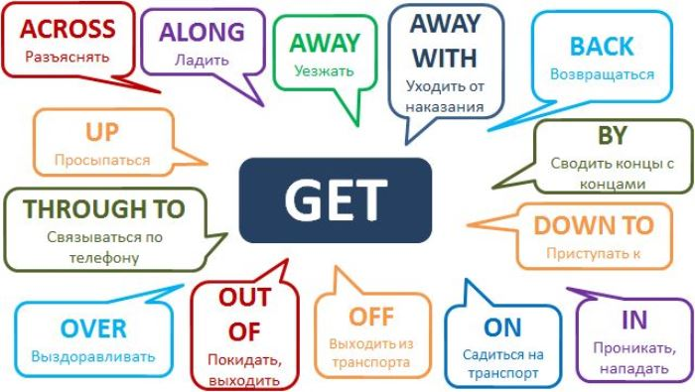 **HOMEWORK**

**Ex 7 p94 составить предложение с фразовым глаголом**

**9А-30.04.2020г.**

**Тема: «Молодежные движения и организации»**

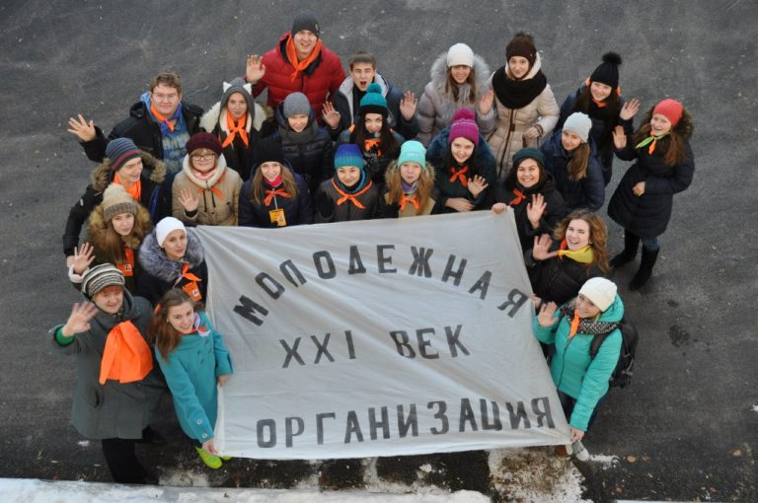

**Ex 3 p 96 (A)**

**Read the text «Young People’s Movements and Organizations»**

**(B) Complete the statements**

**Ex 4 p 97 Ответить на вопросы**

**(67) Аудирование Ex 1 p 95**

**HOMEWORK ребусы по теме урока**

